**Mohana Sreenath K**

RA2111031010021

CSE - IT (R2)

Web Programming

Recipe Box Exprezz

**October 22, 2023**

**Module Name**:

Recipe Box Exprezz

**Purpose:**

Recipe Box Express is a web application module that brings a playful element to meal planning. By rolling a virtual dice, users can instantly receive a random dish recommendation, complete with its name and ingredients. This unique feature is designed to make meal decisions more exciting and spontaneous.

**Functionality:**

This module employs HTML, CSS, and JavaScript to create a user-friendly interface. Users are encouraged to click the "Roll the Dice" button, which triggers a random selection process from a predefined list of dishes. The chosen dish's name and ingredients are then presented, allowing users to embark on their culinary journey with a hint of surprise. The module is also enhanced with charming illustrations to elevate the overall user experience

**Used Software:**

Integrated Development Environment (IDE): Visual Studio Code

Web Development Technologies: HTML, CSS, JavaScript

**Author Name:**

Mohana Sreenath Kodidela

**Illustrations:**

To enhance user engagement, small and delightful illustrations have been integrated into the module.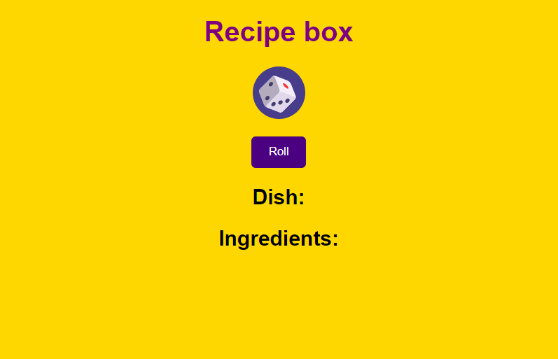

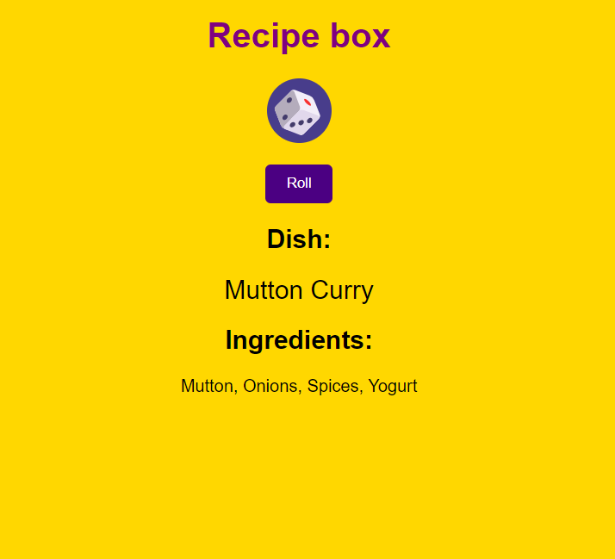

With Recipe Box Express, meal planning becomes an enjoyable adventure, offering a spontaneous and playful way to discover new dishes and flavors. Whether you're an amateur cook or an experienced chef, this module adds a touch of fun to your culinary decisions.